

SYMBIOSIS INTERNATIONAL (DEEMED UNIVERSITY)
(Established under section 3 of the UGC Act 1956)
Re-accredited by NAAC with “A” Grade

Name of the Student: Sneha Sah PRN: 25070122189
Semester: 3 Year: AY 25-29

ASSIGNMENT No: 5
TITLE:
Develop a Java application demonstrating the use of ArrayList, Vector, and StringBuffer for dynamic data storage, management, and string manipulation.
Problem Statement :
Develop a Java application demonstrating the use of ArrayList, Vector, and StringBuffer for dynamic data storage, management, and string manipulation.

Theory:
ArrayList and Vector are dynamic array implementations provided by the Java Collections Framework. ArrayList offers faster performance in single-threaded applications, whereas Vector provides synchronized operations for thread safety. StringBuffer is a mutable sequence of characters that allows efficient string modification without creating new objects. These classes are commonly used in applications requiring dynamic memory allocation and efficient string processing.

Exercise 1
Create a To-Do List application using ArrayList to store tasks and StringBuffer to display tasks.

Source code:

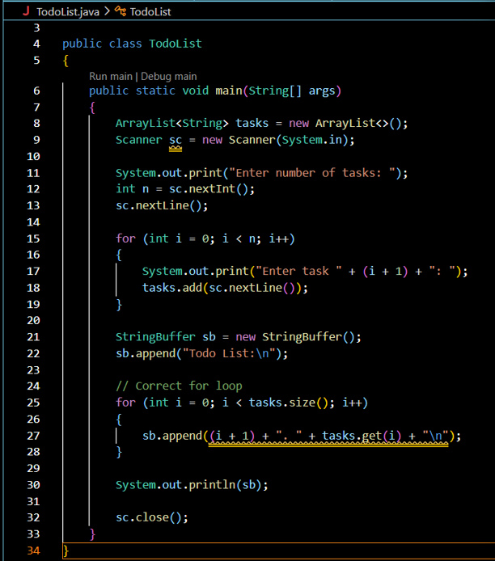
Output:

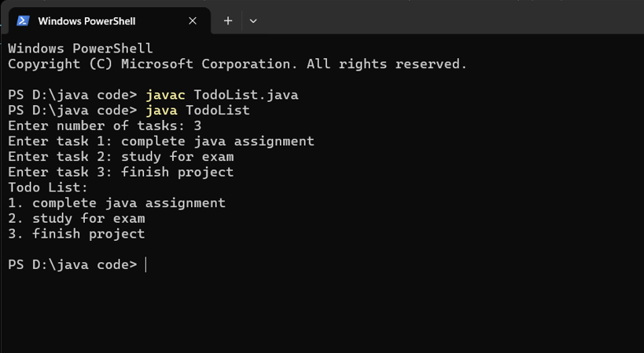
2. Create a Student Course Registration System using ArrayList to store the list of courses registered by a student and StringBuffer to generate and display the registered course list. The application should allow users to add, remove, and view registered courses.

Source code:
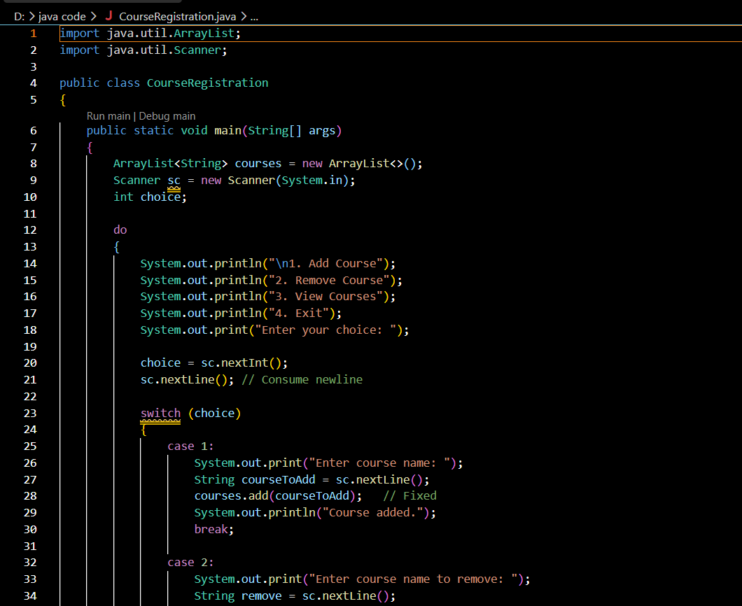
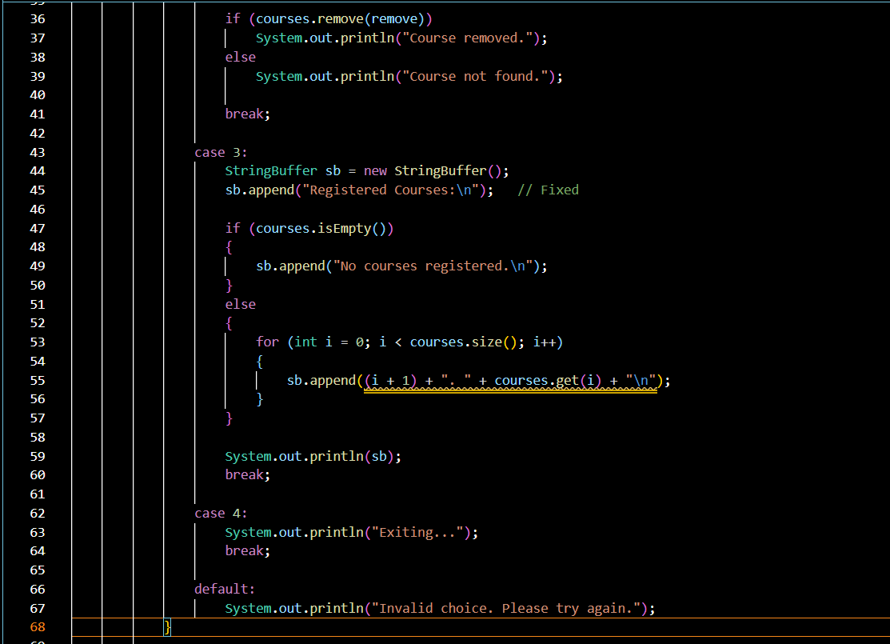

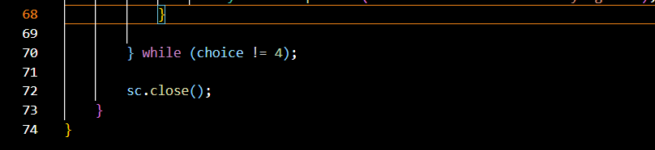

Output:

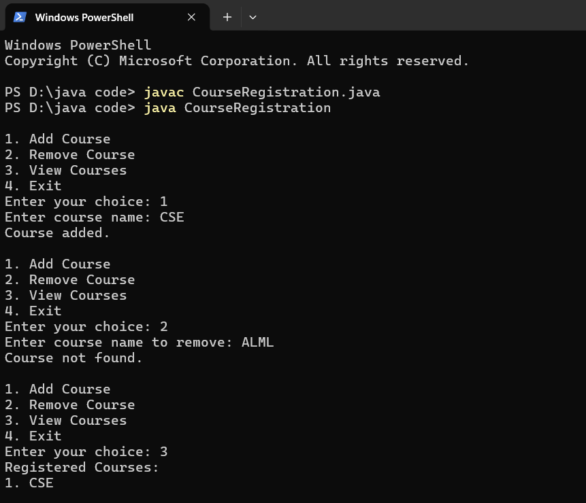
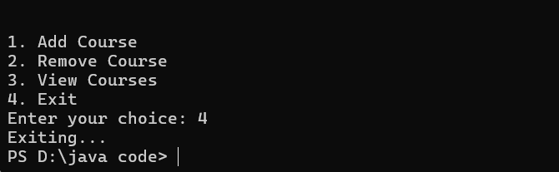

Conclusion :

This assignment helped me understand the practical use of ArrayList, Vector, and StringBuffer in Java. I learned how to store and manage data dynamically, perform operations like adding and removing items, and display information efficiently. I also understood the difference between ArrayList and Vector, and how StringBuffer is useful for efficient string manipulation. Overall, this assignment improved my Java programming skills and gave me practical experience in developing simple, menu-driven applications.

